#include <bits/stdc++.h>
using namespace std;

#define V 5

int minKey(int key[], bool mstSet[])
{
int min = INT_MAX, min_index;

for (int v = 0; v < V; v++)
if (mstSet[v] == false && key[v] < min)
min = key[v], min_index = v;

return min_index;
}

void printMST(int parent[], int graph[V][V])
{
cout<<endl;
cout << " Edge \t Weight\n";
for (int i = 1; i < V; i++)
cout << parent[i] << " - " << i << " \t " << graph[i][parent[i]] << " \n";
}

void primMST(int graph[V][V])
{
int parent[V];
int key[V];
bool mstSet[V];

for (int i = 0; i < V; i++)
key[i] = INT_MAX, mstSet[i] = false;

key[0] = 0;
parent[0] = -1;

for (int count = 0; count < V - 1; count++)
{
int u = minKey(key, mstSet);
mstSet[u] = true;

for (int v = 0; v < V; v++)
if (graph[u][v] && mstSet[v] == false && graph[u][v] < key[v])
parent[v] = u, key[v] = graph[u][v];
}

printMST(parent, graph);
}

int main()
{
int graph[V][V] = {{0, 2, 0, 6, 0},
{2, 0, 3, 8, 5},
{0, 3, 0, 0, 7},
{6, 8, 0, 0, 9},
{0, 5, 7, 9, 0}};

primMST(graph);

return 0;
}

Graph :
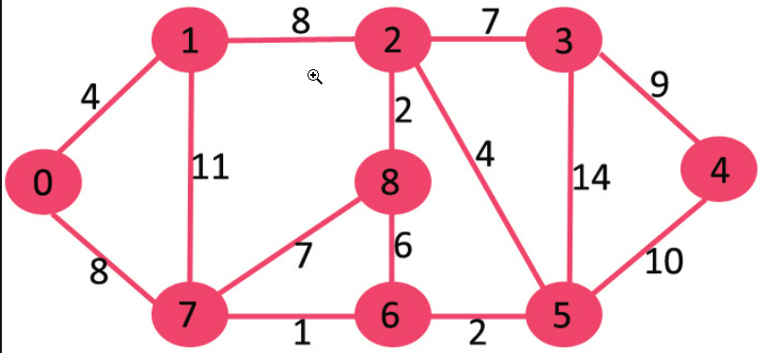

Output :
